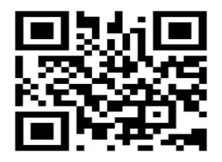

Government Of India

Name =NIDHI

DOB = 24 /03/2006

Gender =Female

ADDRESS= BIJWASAN, New Delhi

0987 6543 7632

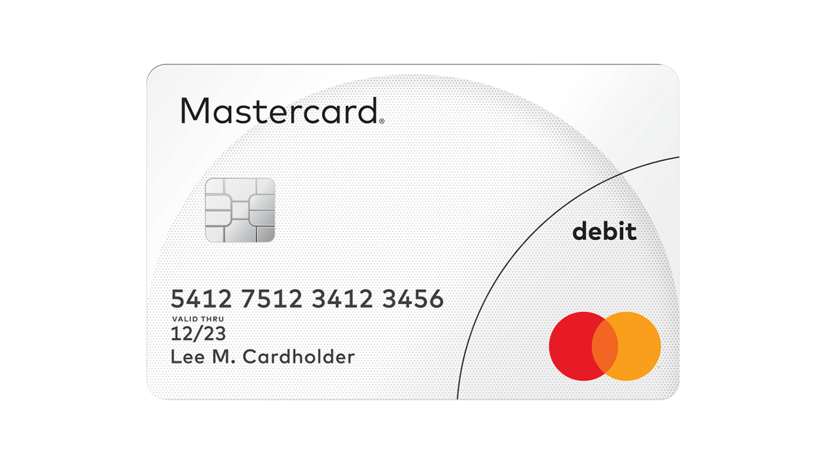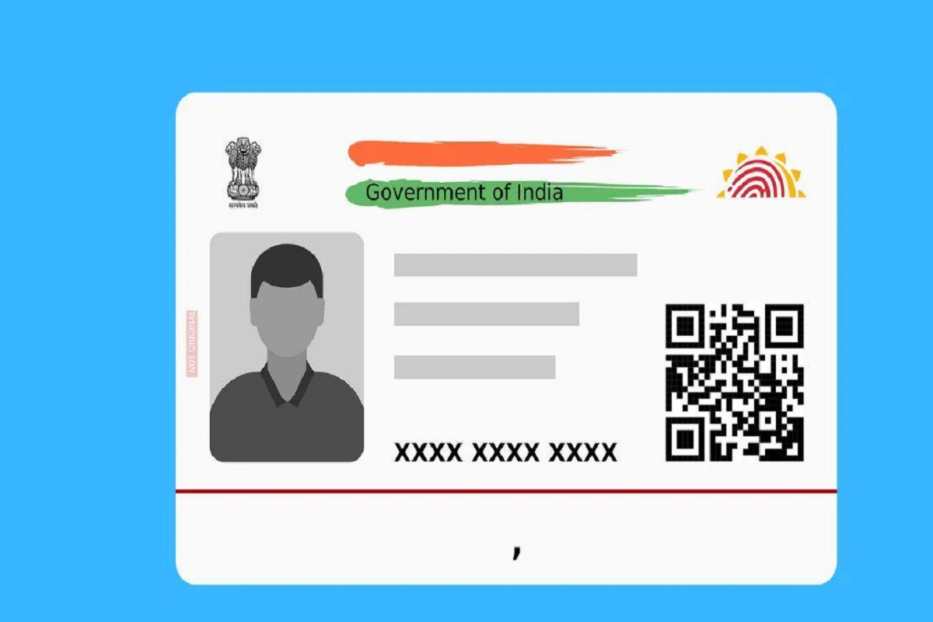

Visa Classic Debit

4000 1234 5678 9876

12/24

c.AR/AS visa